The link to the survey can be found at:

<https://web.cs.dal.ca/~bayer/csci4169/index.html>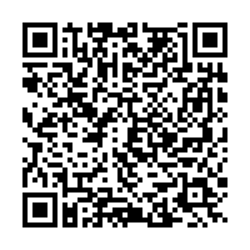

or by using this QR code.